Use-Case Realization Report (Design)
Delete Exam

Issue <1.0>
Revision History
Date | Issue | Description | Author
<05/Sep/09> | <1.0> | <Initial version> | <Thomas Yap>

Table of Contents
1. Brief Description 4
2. Flow of Events 4
2.1 Standard Flow 4
2.1.1 Delete Exam 4
3. Interaction Diagrams 5
3.1 Collaboration Diagram for Delete Exam 5
3.2 Sequence Diagram for Delete Exam 6
4. Participating Objects 7
5. Class Diagrams 7
5.1 Class Diagram for Delete Exam 7
6. Derived Requirements 7

Use-Case Realization Report
Delete Exam

Brief Description
This use case enables the controller to delete multiples choice question profile with its properties and parameters. It involves displaying the menu and select from list to remove the data.

Flow of Events
The standard flow of events for this use case and any exceptions are described in the following subsections. The events are described in terms of Actors and Design Objects.

Standard Flow
This use case covers the Exam Maintenance - Delete Exam. The standard flow of these events is described below.

Delete Exam
The running of the application is shown in section 3.1. The flow of event is as follow:

- When the application start, the first operation to be performed is the startup operation of the main controller. This operation will create all the control objects and the entity objects necessary for operation Delete Exam:
  - The control object created is: MCQBL Controller
  - The entity objects created is: mcq_exam_master Table.

- The main controller will start the main function menu:
  - To start Delete Exam, operation page_load() is activated by MCQBL Controller to display an Exam form.
  - PopulateExamList() is activated and the interface will display the exam list.
  - Operation validation will validate the format of the entries.
  - Then MCQBL Controller will check for additional criteria if any.
  - Portal Admin then select the exam id / ids to be deleted. Upon confirmation by clicking delete button, the record/s will then be deleted from table mcq_exam_master using operation DeleteExam(examID) or DeleteExam(examIDs).
  - The delete request can be cancelled by clicking cancel button and no data will be altered.

- Step 2 will be repeated until all deletions are completion. Then controller will terminate the application by issuing operation close.

Interaction Diagrams

Collaboration Diagram for Delete Exam
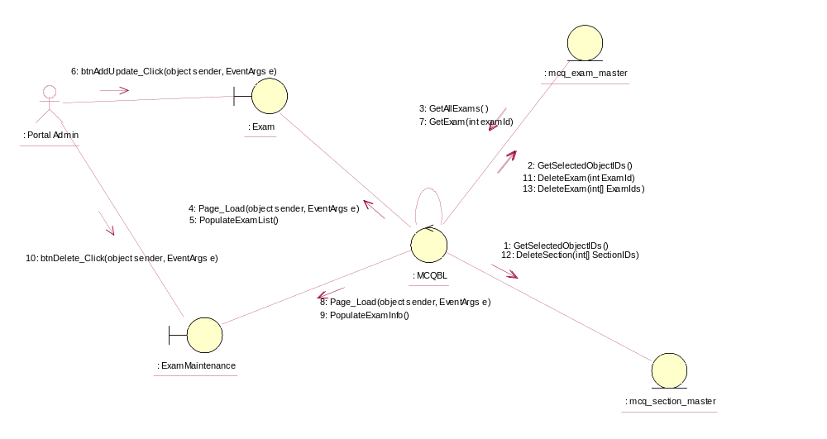

Sequence Diagram for Delete Exam
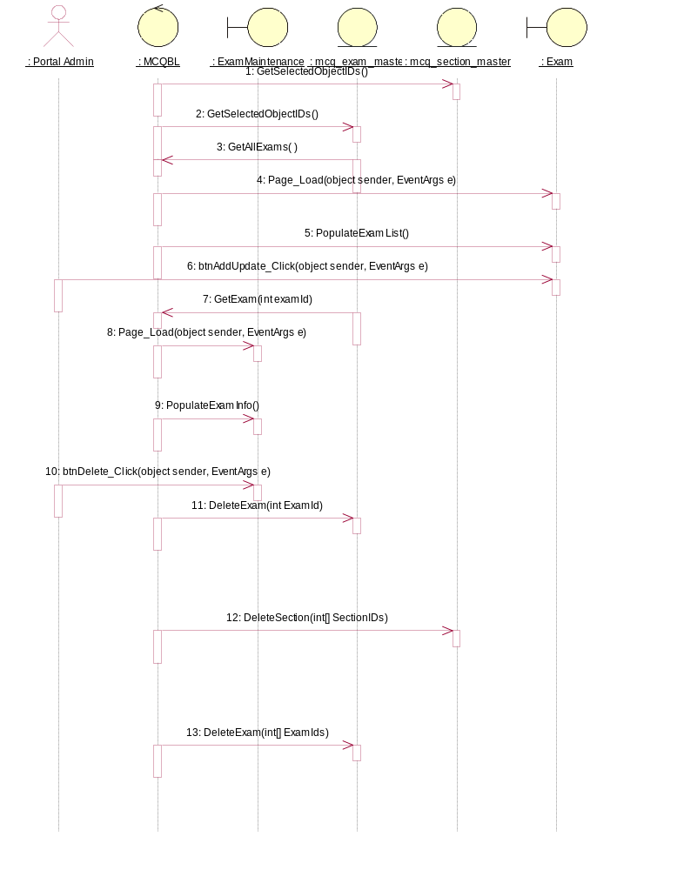

Participating Objects
: Exam

: ExamMaintenance

: mcq_exam_master

: mcq_section_master

: MCQBL

: Portal Admin

Class Diagrams

Class Diagram for Delete Exam
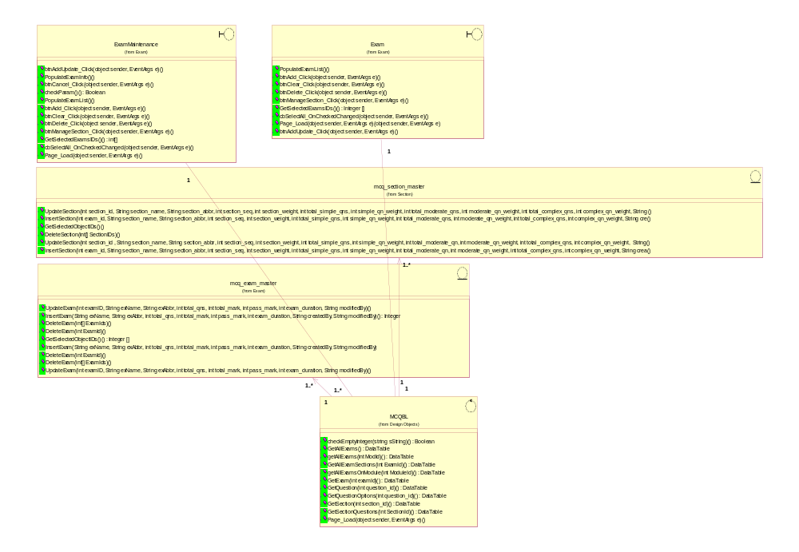

Derived Requirements
[enter the derived requirements here]

